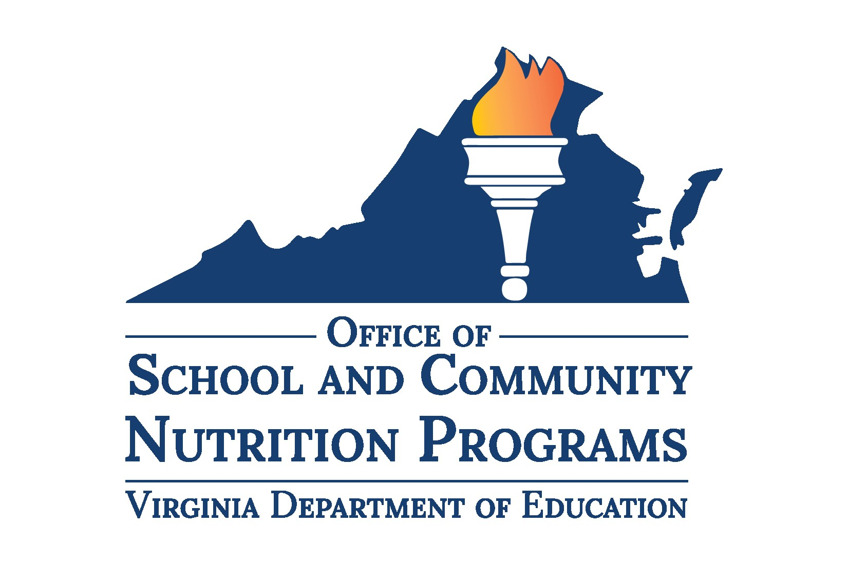

Local School Wellness Policy

Local School Wellness Policy
For the Highlands Juvenile Detention Center
2025
Table of Contents

Leadership 3
Public Involvement¹ 3
School Health Advisory Board² 3
School Meals¹ 3
Foods Sold Outside of the School Meal Programs (Smart Snacks)¹ 5
Foods Provided, Not Sold¹ 6
Food and Beverage Marketing¹ 6
School-Sponsored Fundraisers³ 7
Nutrition Education¹ 8
Nutrition Promotion¹ 8
Physical Education/Physical Activity¹ 9
Other Activities that Promote Student Wellness¹ 10
Triennial Assessment¹ 12
Public Update and Information¹ 12
Recordkeeping 13
Definitions 13
Appendix A: School Health Advisory Board Contacts 14
Appendix B: School Wellness Coordinator Contacts 15
Appendix C: Healthy Celebrations and Rewards 16

Leadership
The Highlands Juvenile Detention Center with support from the health and wellness committee, shall implement and ensure compliance with the Local School Wellness Policy (Wellness Policy) by leading the review, update, and evaluation of the policy.

Public Involvement¹
The division will invite a diverse group of stakeholders from the list below to participate in the development, implementation, and periodic review of the Wellness Policy. All updates and notifications of the HJDC’s health and wellness committee will be through the HJDC Website.
- Administrators
- Classroom teachers
- Physical education teachers
- School food authority (SFA) representatives
- HJDC nurse
- Residents

Detention Health Advisory Board
The HJDC will convene a representative Detention Health Advisory Board (DHAB) that meets at least once per year to establish goals for and oversee school health policies and programs. This board assists with the development, implementation, and periodic review of the HJDC Wellness Policy. The DHAB will include representatives from the school and reflect the diversity of the community to the greatest extent possible. Refer to Appendix A for a list of participants of the DHAB.
The HJDC will designate a wellness policy coordinator who will ensure compliance with the policy and establish an ongoing health and wellness committee that convenes the review of school-level issues in accordance with the division wide DHAB on an annual basis. Refer to Appendix B for a list of health and wellness policy coordinators.

School Meals¹
All schools within the HJDC participate in the National School Lunch Program (NSLP), The NSLP Afterschool Snack Service, and School Breakfast Program (SBP). All meals served to students meet or exceed current nutrition requirements established under the Healthy Hunger-free Kids Act of 2010, as specified in the Code of Federal Regulations at 7CFR210.10 and 7CFR220.8.
The HJDC is committed to serving healthy meals to children with plenty of fruits, vegetables, whole grains, and fat-free and low-fat milk. Meals feature minimally processed and scratch cooked foods from local sources to the greatest extent possible. The meals served meet the nutrition needs of students within their calorie requirements and are moderate in sodium, low in saturated fat, and contain zero grams of trans fat per serving. The school meal programs aim to improve the diet and health of school children, help mitigate childhood obesity, model healthy eating to support the development of lifelong healthy eating patterns and support healthy choices while accommodating cultural food preferences and special dietary needs.
Meal patterns and nutrition standards align with the nutrition recommendations of the Dietary Guidelines for Americans. For more information on the United States Department of Agriculture Food and Nutrition Service (USDA-FNS) child nutrition programs, visit the USDA-FNS Child Nutrition Programs website.
Due to being a secure residential facility, the HJDC will provide breakfast through an adapted alternative breakfast service model to encourage breakfast consumption and ensure access for every student. Students eat breakfast in the classroom (Pod) with their classmates and staff before the beginning of the official instructional day. Food items are packaged as a unit to assure a reimbursable meal is received and to make this model convenient and appealing to students.
All residents at the HJDC are eligible for free and reduced-price meals. The HJDC takes steps to protect the privacy of students who qualify for free or reduced-price meals. Students may not be overtly identified as receiving these benefits and the division has implemented plans to provide meals in a non-stigmatizing manner.
Available funding and resource allocation for student health and wellness are equitable across the HJDC.
Students will be allowed adequate meal times counting from the time they have received their meal and are seated. Adequate meal times include at least 10 minutes to eat breakfast and at least 20 minutes to eat lunch. All mealtimes at the HJDC are scheduled for 30 minutes each.
The HJDC will accommodate students with special dietary needs and follow the USDA regulations outlined in SP 59-2016 to make reasonable modifications to accommodate children with disabilities. This includes providing special meals, at no extra charge, to children with a disability that restricts their diet.
All school nutrition program directors, managers, and staff will meet or exceed hiring and annual continuing education and training requirements as outlined in the USDA Professional Standards for Child Nutrition Professionals website.
The HJDC recognizes water as an essential nutrient and encourages students, staff, teachers, and administrators to model positive hydration behaviors. The HJDC will comply with the USDA regulation eCFR210.10 that requires free, potable water be provided in the cafeteria during breakfast and lunch. Water is not a replacement for milk at meals but rather an additional beverage available to students. Easy access to clean, safe, and good-tasting water is accessible to students and staff during and after the school day. Water sources, such as water fountains, water refill stations, or dispensers, will be regularly maintained. Students are allowed to carry clear water bottles throughout the school day filled with only water.

Foods Sold Outside of the School Meal Programs (Smart Snacks)¹
The HJDC is committed to ensuring that all foods and beverages available to students on the school campus during the school day support healthy eating. All foods and beverages sold outside of the school meal programs shall meet the standards established in the USDA-FNS Nutrition Standards for All Foods Sold in Schools (Smart Snacks) rule. These standards will apply in all locations and to all services where foods and beverages are sold, which may include, but are not limited to, a la carte options in cafeterias, vending machines, school stores, and snack or food carts.
All snacks sold and served to students outside of school hours on the school campus, including before and after school care, clubs, and after school programming, will meet the same nutrition standards as food sold during the school day.
Beverages containing caffeine will not be sold on high school campuses.
The USDA’s Tools for Schools: Focusing on Smart Snacks website provides resources to assist schools, parents, and teachers with identifying food items that meet the USDA-FNS Smart Snacks criteria and ways to encourage children to make healthier snack choices.

Foods Provided, Not Sold¹
Celebrating success or events with poor nutritional quality foods can undermine healthy eating messages and lead to unhealthy eating habits that can continue into adulthood. The division requires foods offered on the school campus meet or exceed the USDA-FNS Smart Snacks rule including those provided at celebrations or classroom snacks by staff or family members. Compliant products are available through the HJDC School Nutrition Department. Contact the school nutrition director for more information.
Foods and beverages will not be used as a reward, or withheld as punishment for any reason, such as for performance or behavior.
Refer to Appendix C for a list of healthy celebration and snack ideas that meet the USDA-FNS Smart Snacks rule. The division will provide this list to parents, teachers, and students annually in the student handbook or school newsletter.

Food and Beverage Marketing¹
The HJDC will restrict food and beverage marketing to only those foods and beverages that meet the nutrition standards set forth by the USDA-FNS Smart Snacks rule. Marketing will promote healthy food and beverage choices.
Food advertising and marketing is defined as an oral, written, or graphic statement made for the purpose of promoting the sale of a food or beverage product. Marketing on the school campus includes, but is not limited to:
- brand names, trademarks, logos or tags, except when placed on a physically present food or beverage product or its container;
- displays, such as on vending machine exteriors;
- brands, logos, or trademarks on school equipment, such as marquees, message boards, scoreboards, or backboards;
- brands, logos, or trademarks on cups, menu boards, coolers, recycle and trash cans, and other food service equipment;
- brands, logos, or trademarks on posters, book covers, pupil assignment books, or school supplies displayed, distributed, offered, or sold by the division;
- advertisements in school publications or school mailings;
- free product samples, taste tests, or coupons of a product; and
- fundraisers and corporate-incentives programs.
Immediate replacement of large items is not required; however, the HJDC will update equipment to be in compliance with food and beverage marketing standards outlined in this policy as items are replaced.

School-Sponsored Fundraisers
As part of a political subdivision, the HJDC does not sponsor, nor participate in, fundraising activities.

Nutrition Education¹
The HJDC will provide at least 140 minutes of nutrition education and exceed the expectations of the Virginia Department of Education Health Standards of Learning (SOLs) by integrating nutrition concepts and skills into mathematics, language arts, social science, and/or other courses throughout the school year. The HJDC will reinforce nutrition education provided in the classroom during enrichment activities.

Nutrition Promotion¹
The HJDC will promote positive nutrition habits in the classrooms, and throughout the HJDC environment.

Physical Education/Physical Activity¹
The HJDC will provide every student with physical education that exceeds the expectations of the VDOE Physical Education SOLs and teaches the skills needed to achieve and maintain a health-enhancing level of personal fitness and develop the knowledge, attitudes, behaviors, and confidence needed to be physically active for life. A program of physical activity is available to all students in grades six through 12 with a goal of at least 150 minutes per week on average during the school year.
Students will be moderately to vigorously active for at least 50 percent of class time during all physical education class sessions.
All students will be provided an equal opportunity to participate in physical education classes. The HJDC will make appropriate accommodations to allow for equitable participation for all students and will adapt physical education classes and equipment as necessary.
All physical education classes in the HJDC are taught by licensed teachers endorsed to teach physical education. All physical education teachers will be required to participate in professional development at least once per year.
Physical activity may not be withheld as punishment.

Other Activities that Promote Student Wellness¹
The HJDC will seek to provide school climates that support social and emotional wellbeing and promote positive relationships among students, staff, parents, and community members. Schools will provide students with instruction to increase self-awareness, self-management, social awareness, relationship skills, and responsible decision-making. Schools will seek to identify students who may have mental health concerns, challenges, and/or traumatic experiences to provide parents and students with referrals to appropriate mental health providers in the school and community. Schools will develop curricula and implement trainings for staff, students, and parents on recognizing the signs of mental illness and emotional distress and strategies for addressing their needs.
The HJDC has appropriate hand-washing facilities and/or hand-sanitizing mechanisms located throughout the building to ensure proper hygiene prior to eating.
The HJDC will provide the health screenings of residents by the center nurse for general health issues based on state guidelines and requirements and according to the HJDC protocol.
Each resident upon admission shall immediately undergo a preliminary health screening consisting of a structured interview and observation by health care personnel or health trained staff before being transferred to the general population. This health screening must be approved by the center’s health authority and be utilized to identify and prevent newly-arrived residents who pose a health or safety threat to themselves or others from being placed in general population. Residents identified as a health or safety threat to themselves or others shall be separated from the general population until they are deemed no longer a risk. Residents separated from the general population shall receive comparable services.

Triennial Assessment¹
The HJDC will evaluate compliance with the Wellness Policy at least once every three years. The assessment will include the extent to which each school is in compliance with the policy, the extent to which the policy compares to a model policy, and a description of the progress made in attaining the goals of the policy.
The position/person responsible for managing the triennial assessment and contact information is Neil Bramlette nbramlette@hjdc.org
The school wellness coordinator at each school will complete the VDOE School Level Report Card or other assessment tool. The results of the report card/tool will be submitted to the wellness policy designee in order to analyze the findings and develop the triennial assessment. The wellness policy designee will actively notify the community of the results of the triennial assessment by posting on the HJDC website. The results of the triennial assessment, as well as the latest national and state recommendations pertaining to school health, will be used to update the goals and language in the HJDC Wellness Policy.

Public Update and Information¹
Each school year the division will actively inform families and the public about the content of and any updates to the Wellness Policy through the HJDC website.
The Wellness Policy and any updates can be found on www.HJDC.org.

Recordkeeping
The division will retain records to document compliance with the requirements of the Wellness Policy at the HJDC. Documentation maintained at this location will include, but is not limited to:
- the written Wellness Policy;
- documentation demonstrating compliance with community involvement requirements:
  - requirements to make the Wellness Policy available to the public;
  - requirements to make the triennial assessment available to the public;
- documentation of the triennial assessment at each school under the LEAs jurisdiction; and
- documentation of methods the division uses to make stakeholders aware of their ability to participate in the development, implementation, and periodic review and update of the Wellness Policy.

Definitions
Competitive Foods – All food and beverages other than meals reimbursed under the federal meal programs available for sale to students on the school campus during the school day.
School Campus – For the purpose of competitive food standards implementation, school campus means all areas of the property under the jurisdiction of the school that are accessible to students during the school day. This includes the outside of the school building, school buses or other vehicles used to transport students, athletic fields, and stadiums (e.g., on scoreboards, coolers, cups, and water bottles), or parking lots.
School Day – For the purpose of competitive food standards implementation, school day means the period from midnight the night before to 30 minutes after the end of the instructional day.
Triennial – Recurring every three years.

Appendix A: School Health Advisory Board Contacts
Name | Title/Organization | Email
Trey Murray | Executive Director, HJDC | tmurray@hjdc.org
Bo Love | Principal, BVPS | blove@bvps.org
Jessica McCarty | Food Services Manager, HJDC | jmccarty@hjdc.org
Steve Bonney | Phys Ed Teacher, BVPS | sbonney@bvps.org

Appendix B: School Wellness Coordinator Contacts
Name | Title | School | Email
Jessica McCarty | Food Services Manager | HJDC | jmccarty@hjdc.org

Appendix C: Healthy Celebrations and Rewards

Healthy Snack and Beverage Ideas*
Beverages | Fruits and Vegetables | Whole Grains | Proteins
Water | Fruit trays, salads, or fruit kabobs | Whole grain crackers, pretzels, or cereal bars | Trail mix with nuts, seeds, and dried fruit
Fruit-infused water | Vegetable trays, salads, or vegetable kabobs | Low-fat or air-popped popcorn with no added butter or salt | Seed butter served with fruit or whole grain crackers
100% fruit juice with no added sugar | Canned fruit or fruit cups in water or 100% fruit juice | Small whole grain bagels, waffles, or pancakes topped with fruit or seed butter | Fat-free or low-fat yogurt served alone or as a fruit or vegetable dip
Fruit smoothies made with frozen fruit with no added sugar and low fat yogurt | Frozen fruit, such as grapes, strawberries, or blueberries | Graham crackers | Low-fat cheese served with fruit or whole grain crackers
100% fruit juice slushes with no added sugar | Dried fruit with no added sugar | Baked whole grain tortilla chips with salsa or bean dip | Hummus served with vegetables or whole grain crackers
*Work with your division’s nutrition service staff to purchase Smart Snacks compliant foods and beverages for celebrations. Review students’ food allergies before serving any food or beverage item. Non-food celebrations and healthy food and beverage ideas come from the Alliance for a Healthier Generation's Celebrations that Support Child Health.

Requirement by Code of Federal Regulations: Local School Wellness Policy (7CFR210.31)
Recommended best practice by the Virginia Department of Education, Office of School and Community Nutrition Programs
Requirement by Virginia Code: Regulations Governing Nutritional Standards for Competitive Foods Available for Sale in Public Schools (8VAC20-740)

